1. From the main menu, select **Metadata Modeller > Create Metadata**.

* 1. 2. In the **Metadata Summary** section of the **Create Metadata** window set the following values: a. Family: **No Family**
  2. b. Priority: **101**
  3. c. Name: **Building Metadata EXAM**
  4. d. Type: **Other**

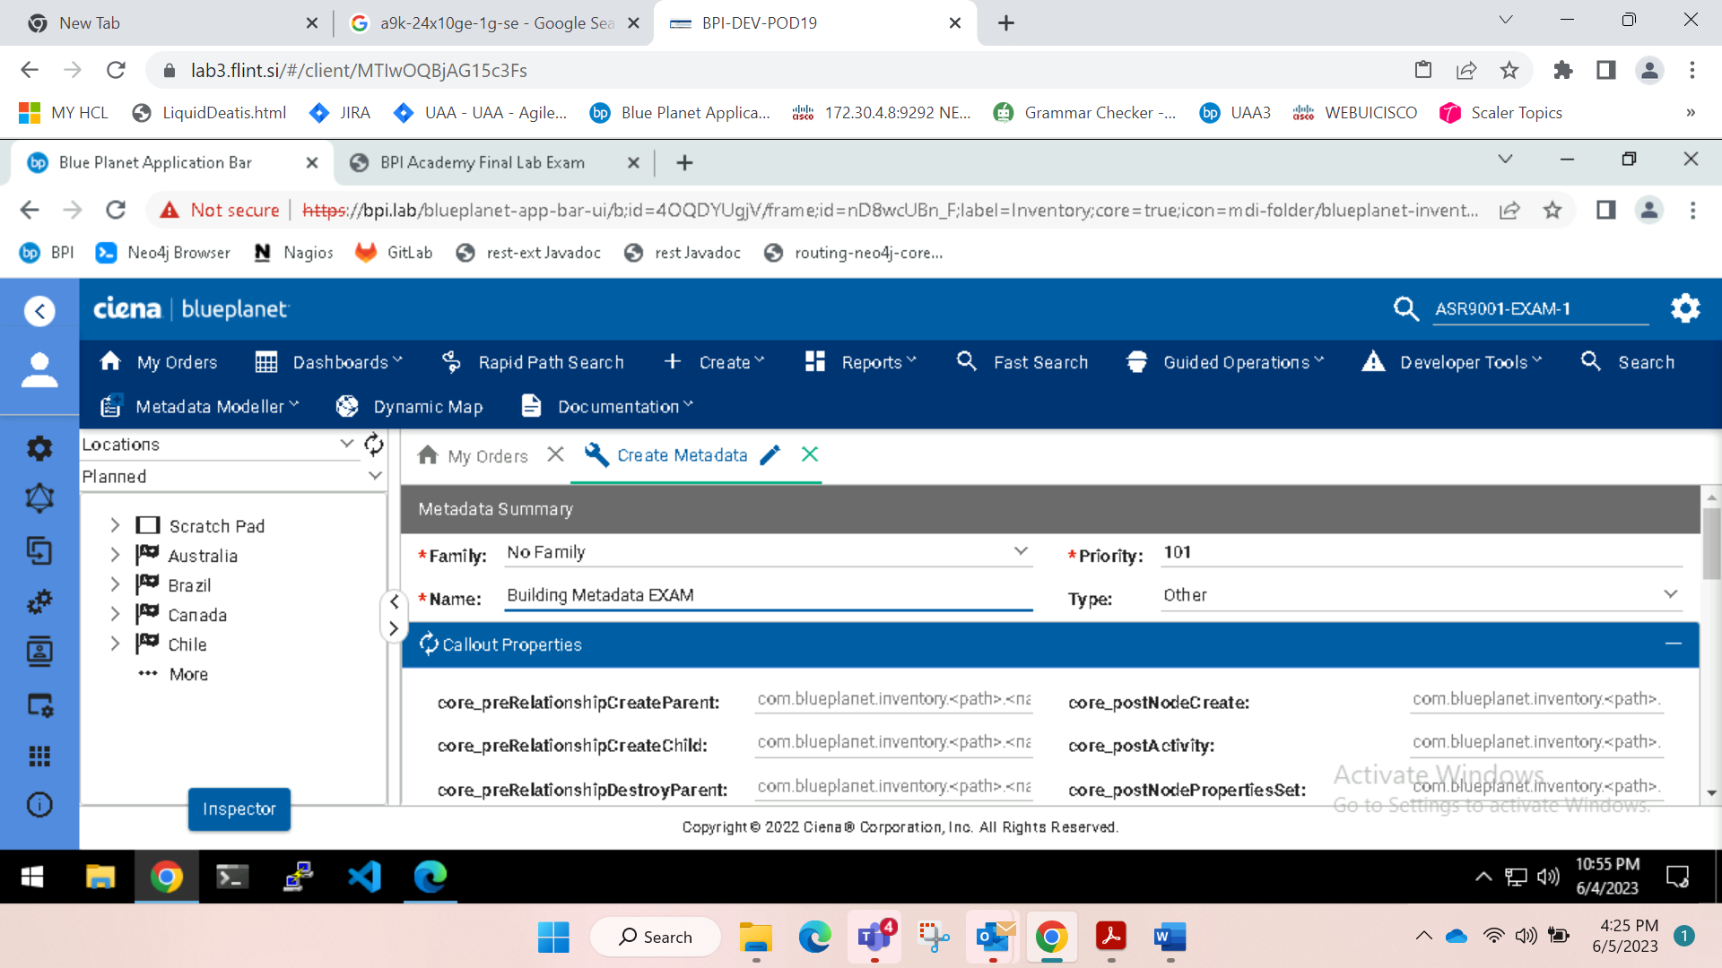

In the **Additional Properties** section, add the **uifields** property with the data type **json** and set the value of the property to:

{

"properties": [

{

"group": "Custom Building Details",

"uiFormFields":[

{

"name": "buildingType",

"label": "Type",

"visible": "true",

"type": "DROPDOWN",

"required": "false",

"versioned": "false",

"value": "",

"options": [

{ "label": "Cloud Computing", "value": "Cloud_Computing" },

{ "label": "Co-Location", "value": "Co_Location" },

{ "label": "High Performance Computing", "value": "High_Performance_Computing" },

{ "label": "Enterprise", "value": "Enterprise" },

{ "label": "Edge Data Center", "value": "Edge_Data_Center" }

]

}

],

"versionedRelationshipType": "CONTAINS_PROPERTIES" }

]

}

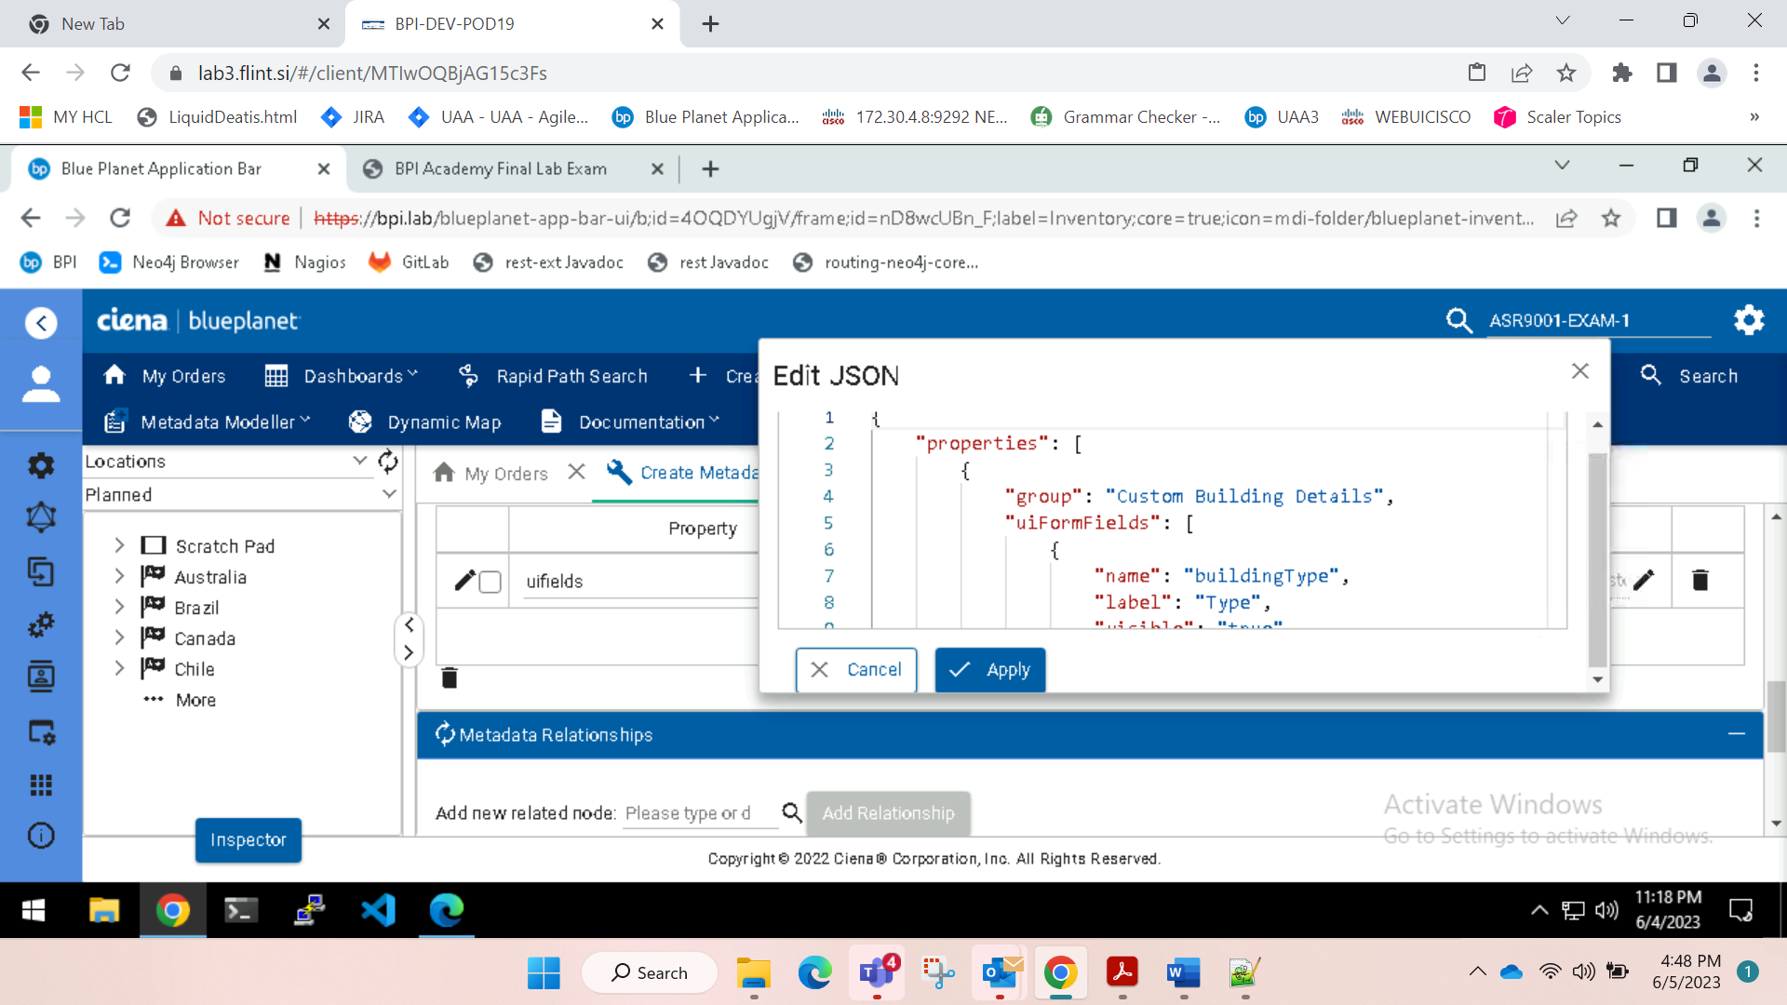

Apply

Add building in metadata relation

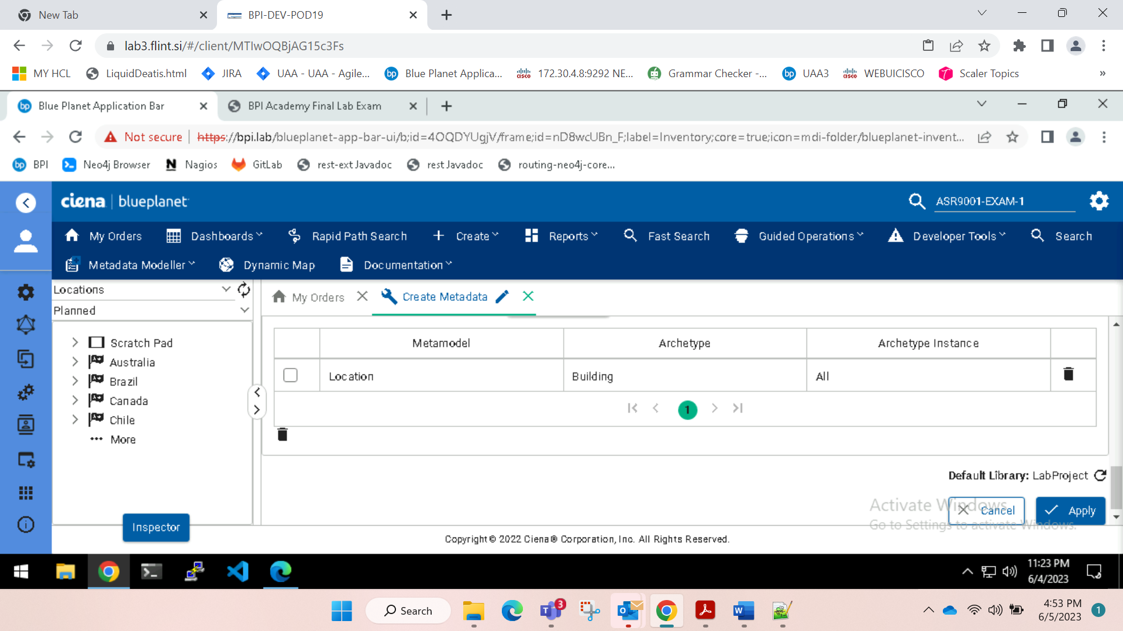

And apply

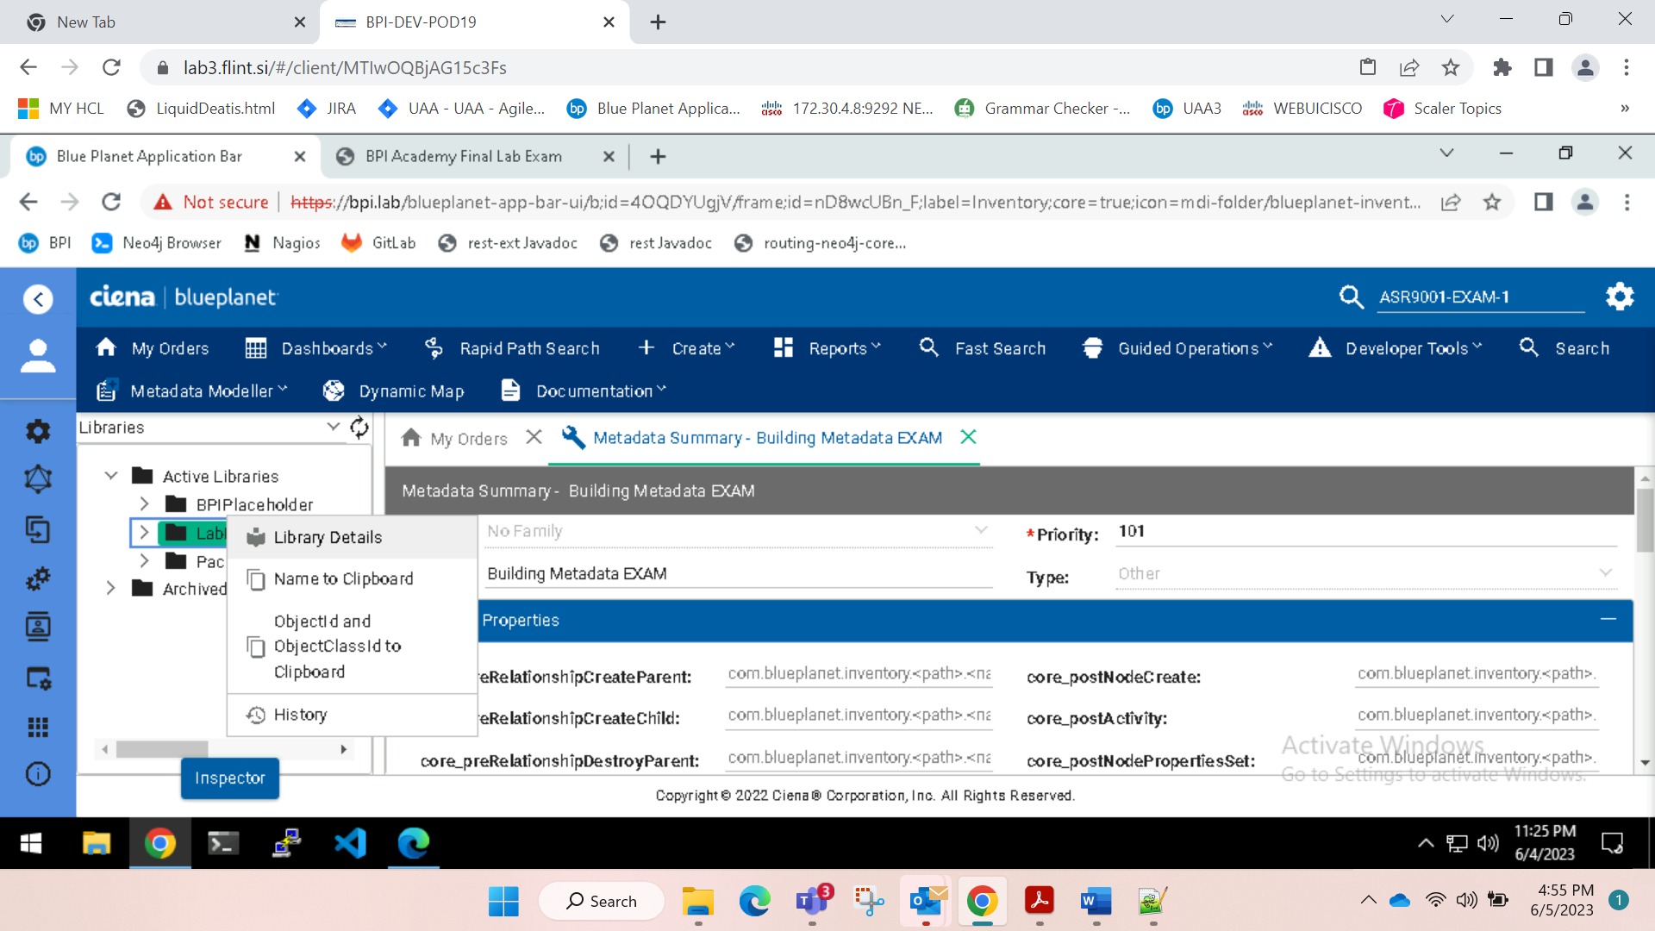

Tag and deploy

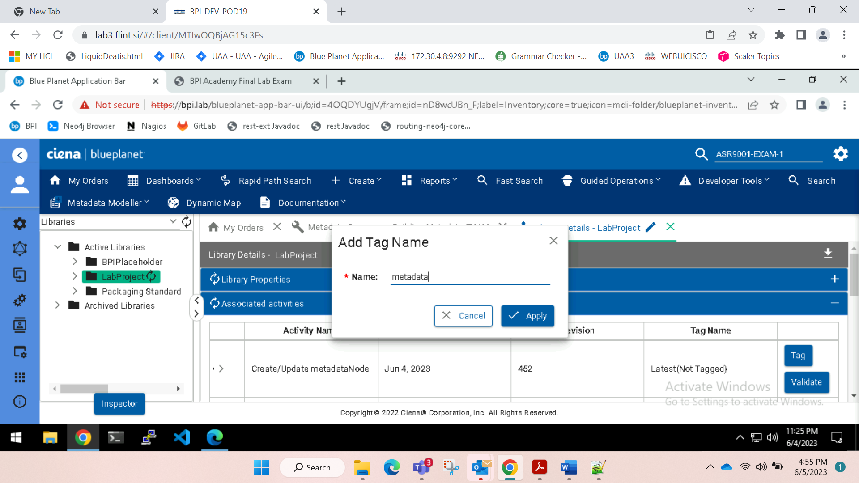

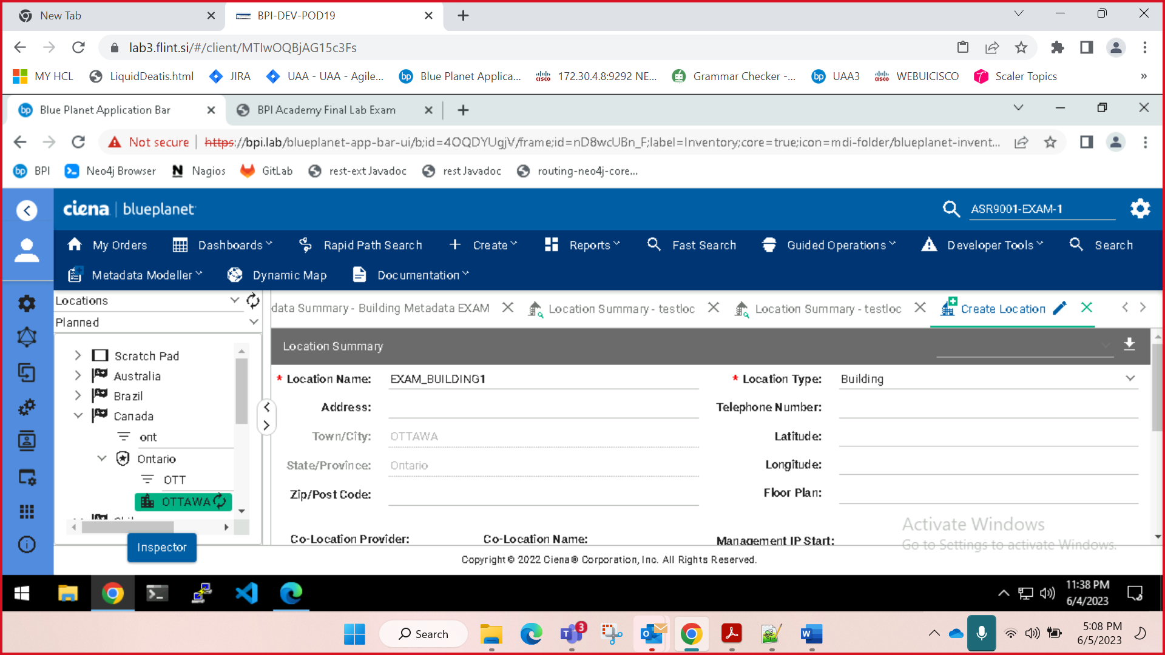

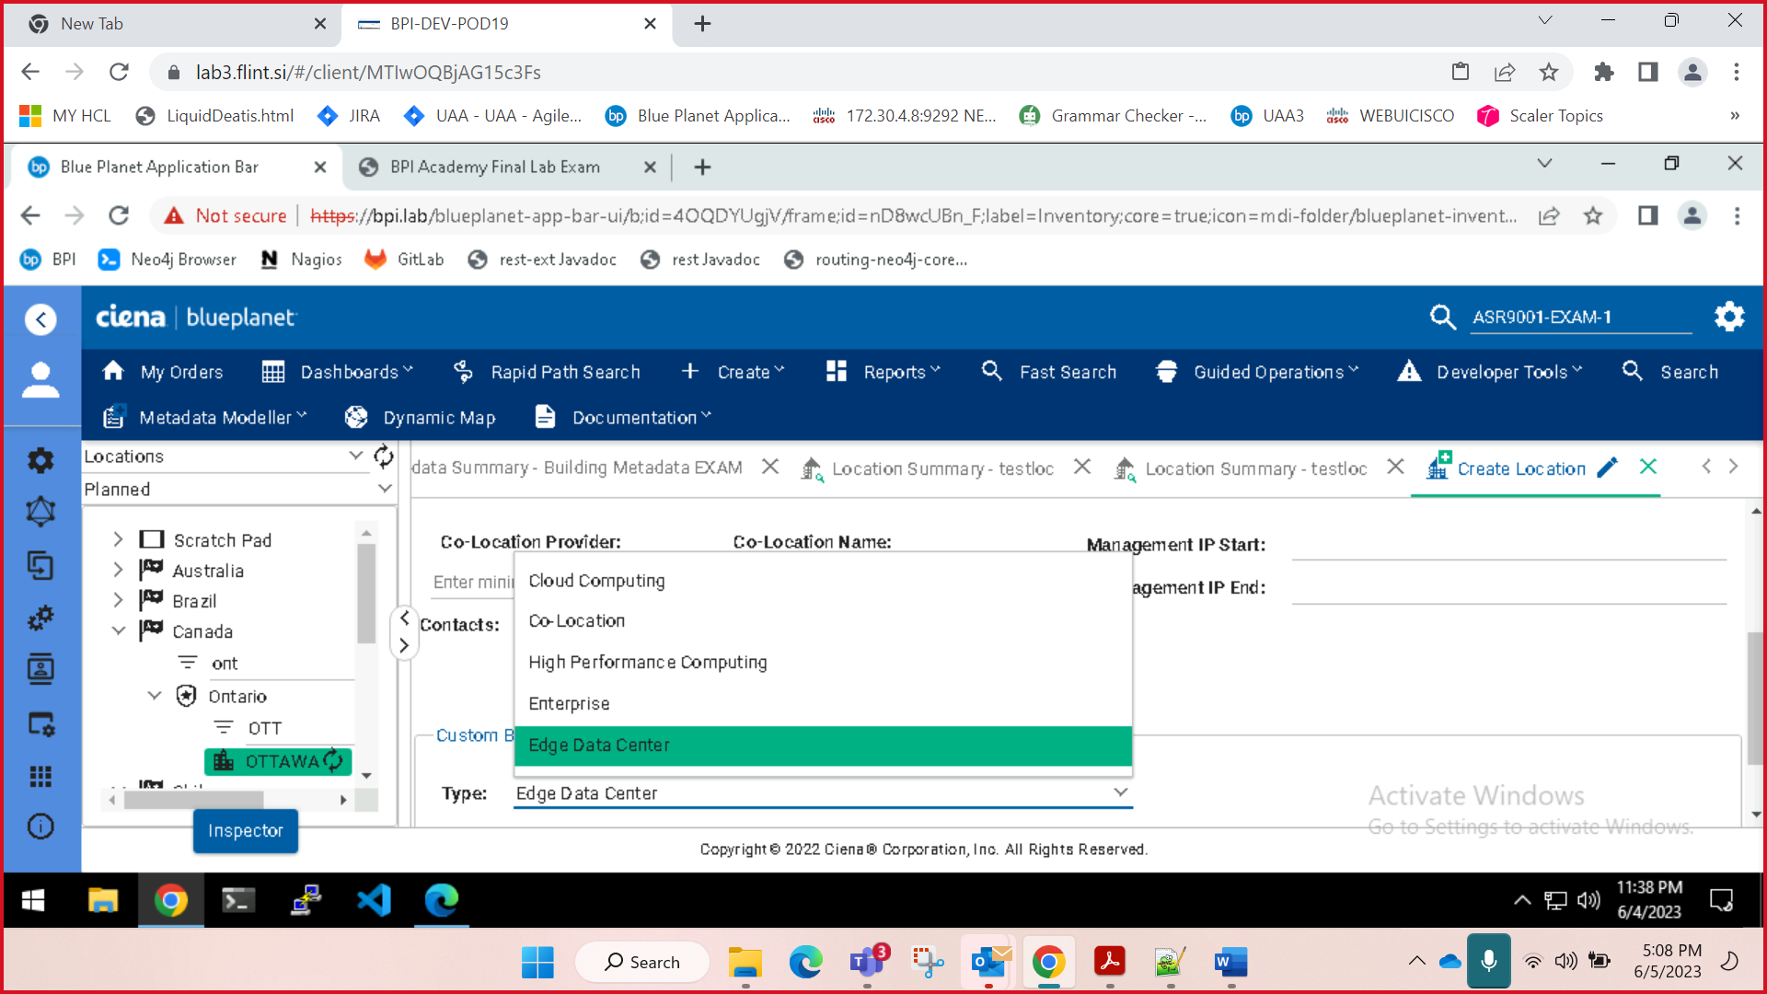

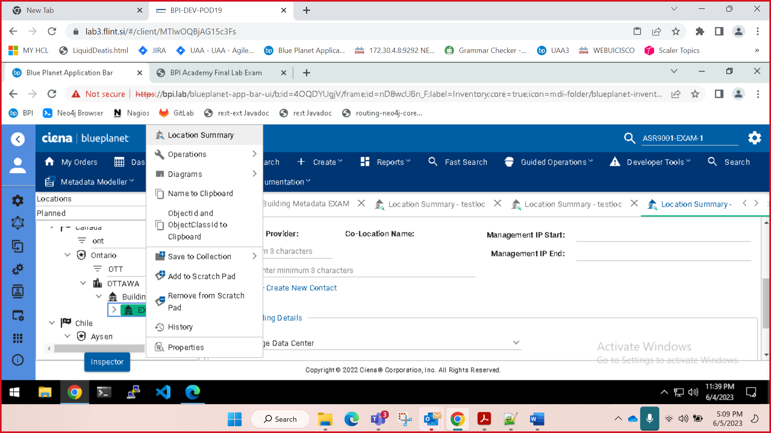

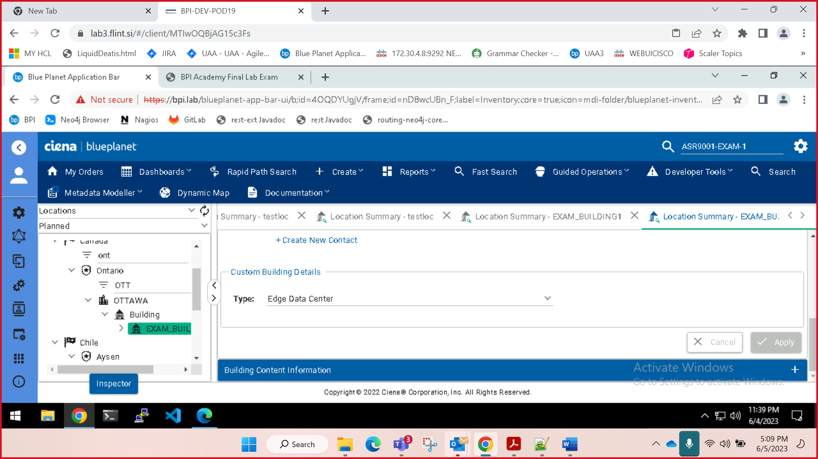

2nd

* 1. At the top section of the **Create Metadata** page, enter the following values: a. Family: **No Family**
  2. b. Priority: **101**
  3. c. Name: **Device Metadata EXAM**
  4. d. Type: **Other**

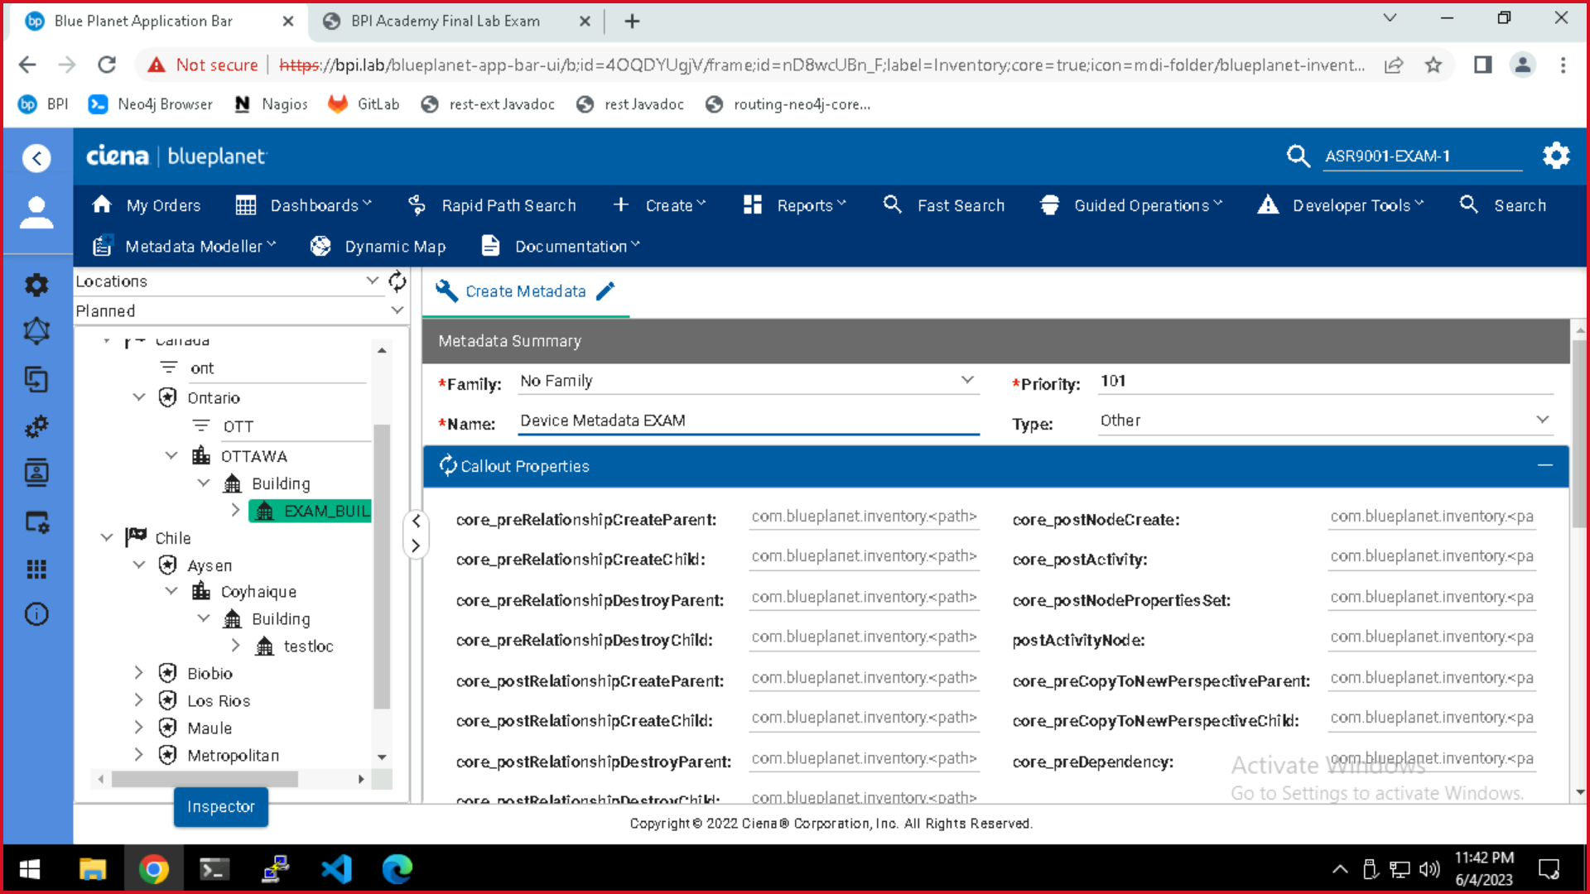

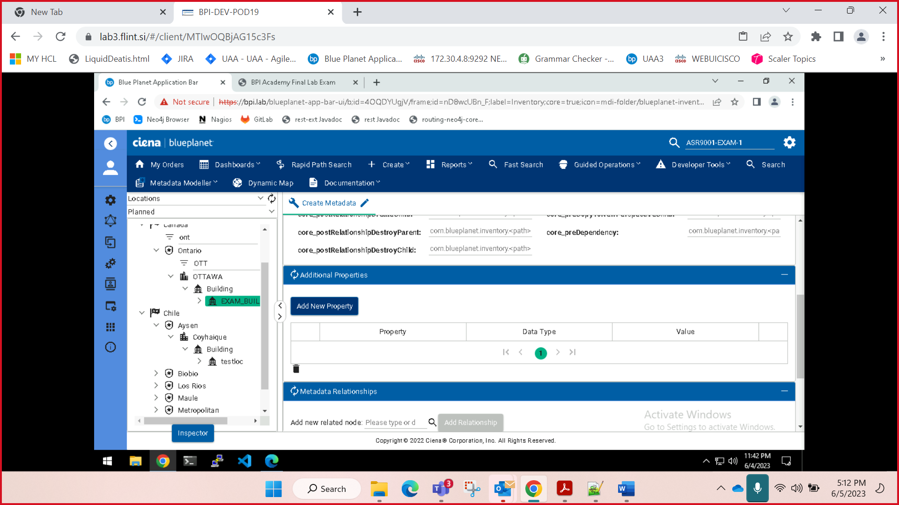

* 1. In the **Additional Properties** section, click the **Add New Property** button. In the table below the button, a new row entry should appear. For that entry, set the following values: a. Property: **uifields**
  2. b. Data Type: json

{

"properties": [

{

"group": " Custom Device Details",

"uiFormFields":[

{

"name": "equipmentClli",

"label": "CLLI",

"visible": "true",

"type": "TEXT",

"required": "false",

"versioned": "false",

"value": ""

},

{

"name": "clei",

"label": "CLEI",

"visible": "true",

"type": "TEXT",

"required": "false",

"versioned": "false",

"value": ""

},

{

"name": "description",

"label": "Description",

"visible": "true",

"type": "TEXTAREA",

"required": "false",

"versioned": "false",

"value": ""

}

],

"versionedRelationshipType": "CONTAINS_PROPERTIES" }

]

}

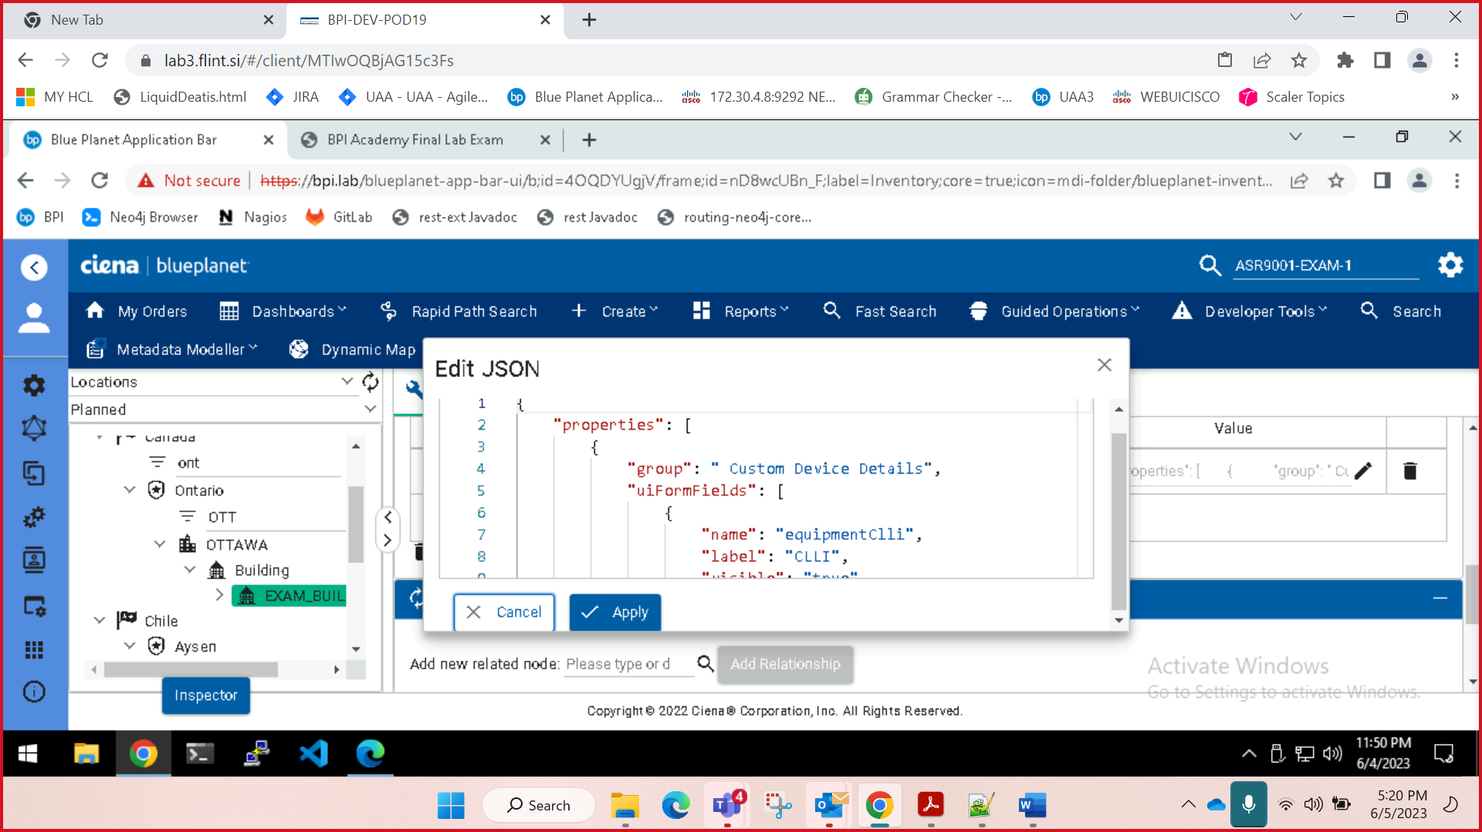

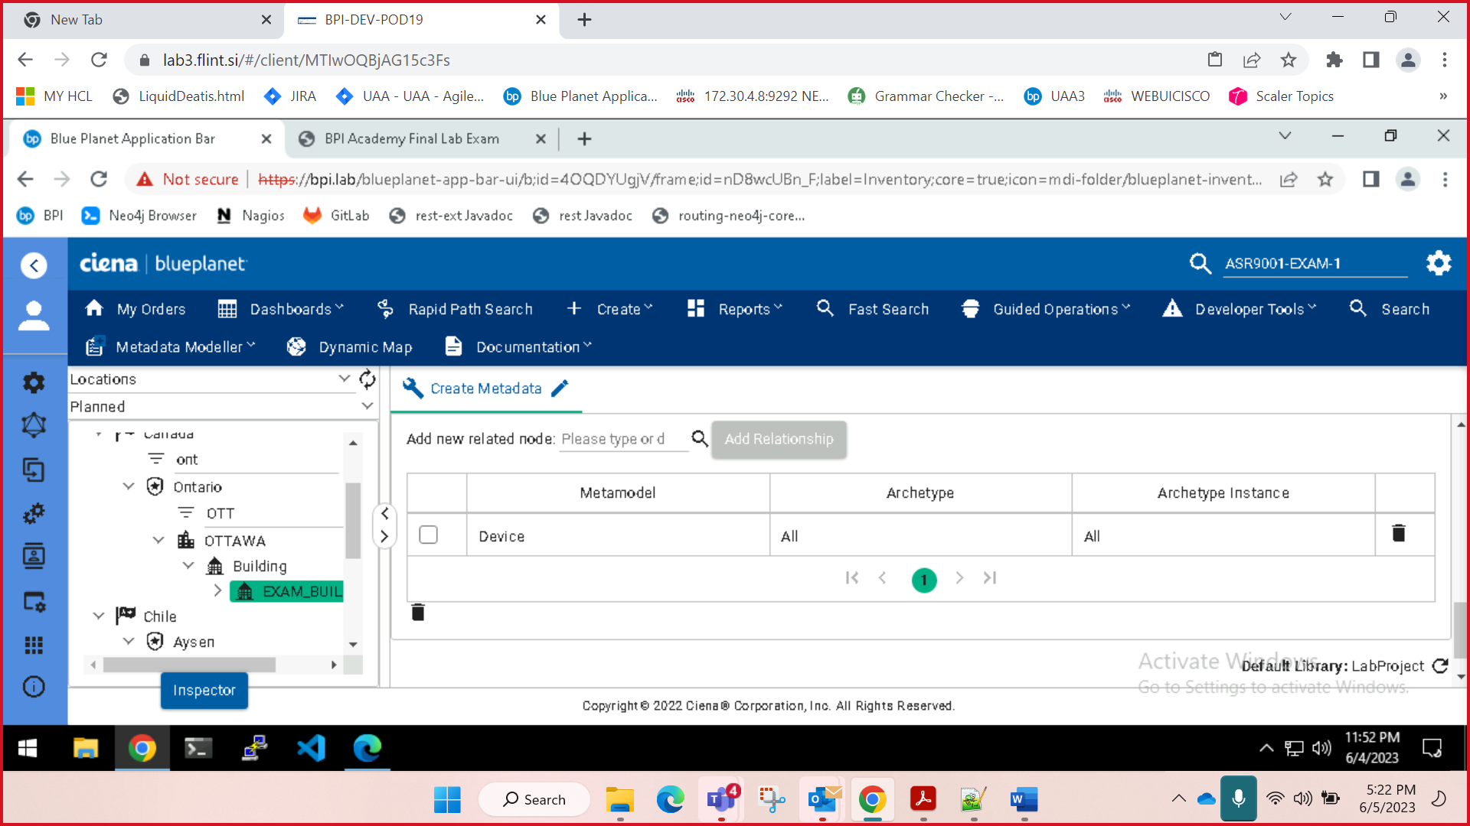

Add relationship “Device”

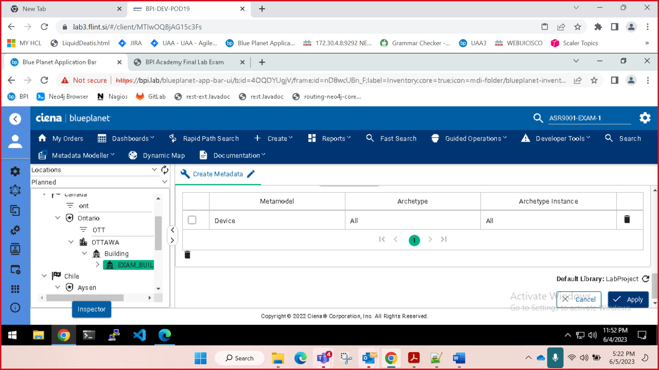

Apply

Tag

Deploy

